SARAPP sa UP
Search and Rate Application sa UP
Analysis Model

Submitted to:

Asst. Prof. Ma. Rowena C. Solamo
Faculty Member
Department of Computer Science
College of Engineering
University of the Philippines, Diliman

Submitted by:
Jennie Ron S. Ablog
John Arjude C. Gerona
John Christian E. Sun

In partial fulfillment of Academic Requirements
for the course
CS 191 Software Engineering I
of the
1st Semester, AY 2016-2017
Revision Control

History Revision:
Revision Date | Person Responsible | Version  Number | Modification
10/21/16 | John Christian E. Sun | 1.0 | Created and uploaded the initial document.

Purpose:

To identify, define and document the analysis classes of the system.

Audience:

This document serves as a partial fulfillment of academic requirements for the CS 191 Software Engineering course, handled by Ma'am Rowena Solamo, to whom this document is made for.
System Name: SARAPP sa UP system

Description: [Brief Description of the System in 3-7 sentences.]

Class Diagram:

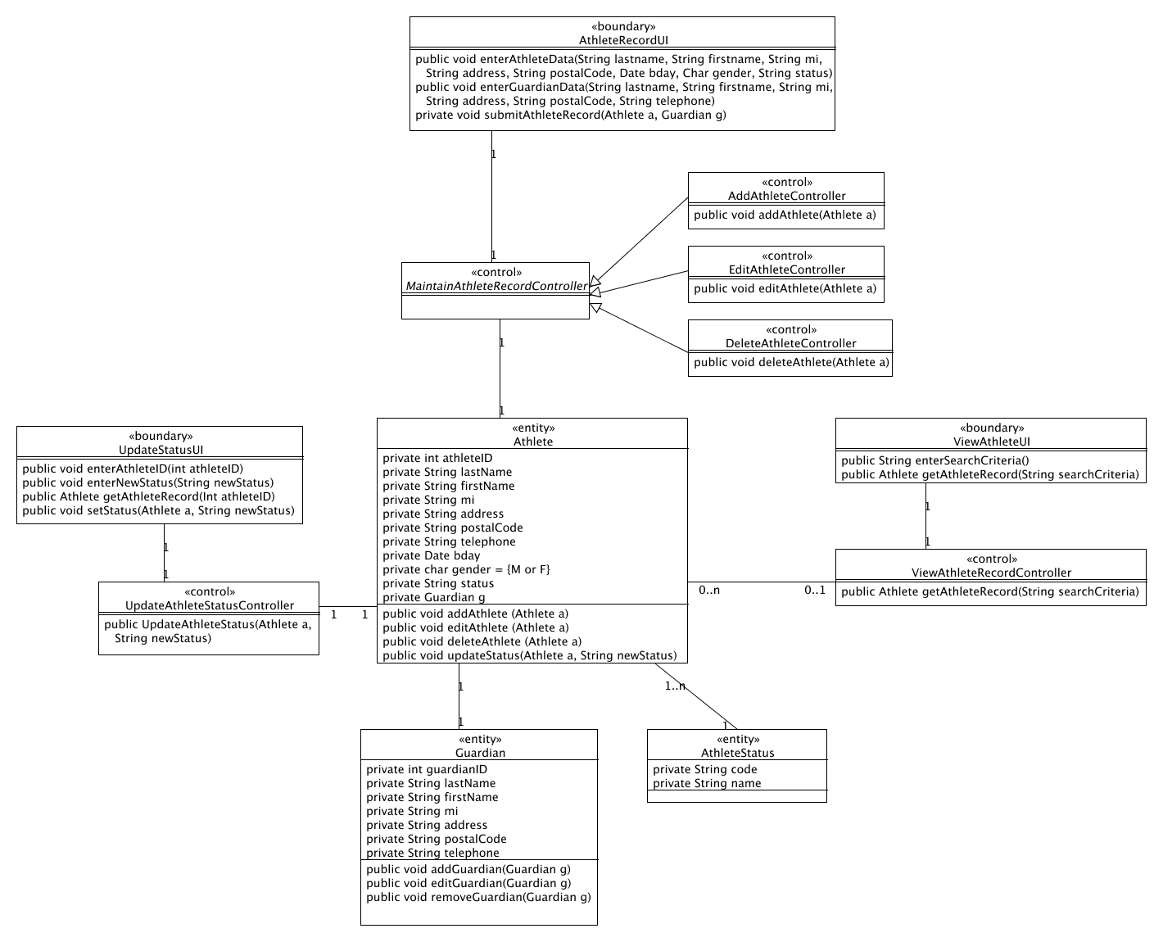

Boundary Classes:

Class Name | Description

Control Classes:

Class Name | Description

Entity Classes:

Class Name | Description

